7.2A – 1 (S) one Y
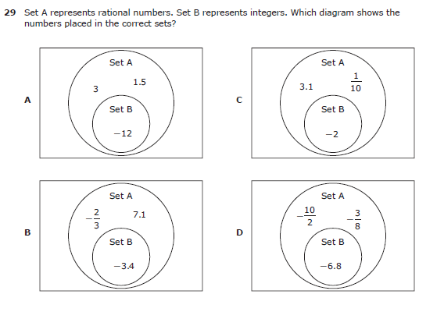
7.2A – 1 (S) two Z
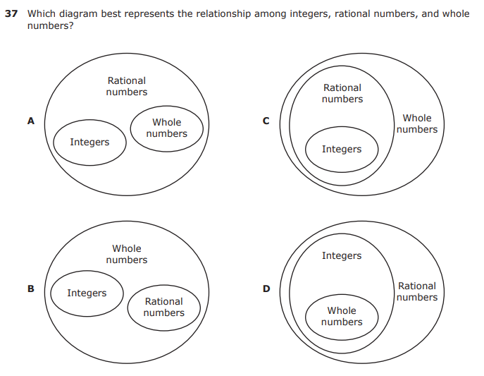
7.3A– 2 (S) three J
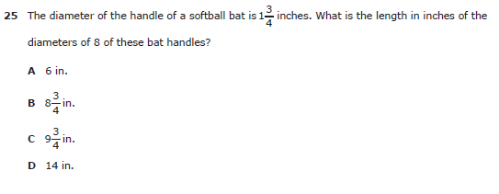

7.3A – 2 (S) four W
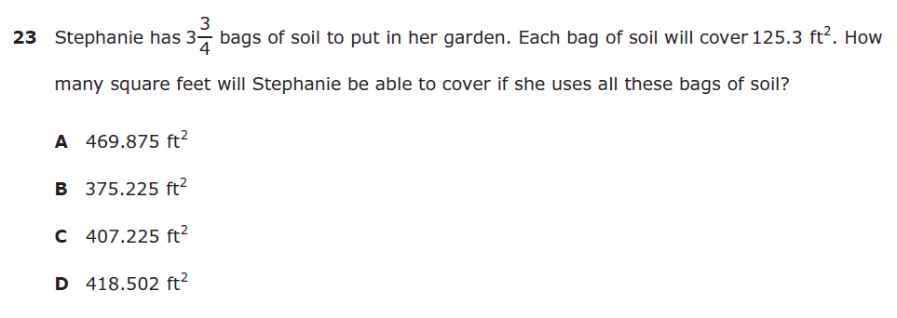

7.3A – 2 (S) five -19.8
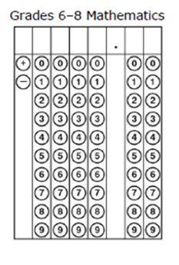
7. 4B – 2 (S) six X
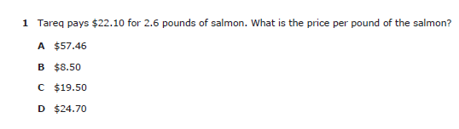

7.4B – 2 (S) seven 11.75
7.4C – 2 (S) eight Z
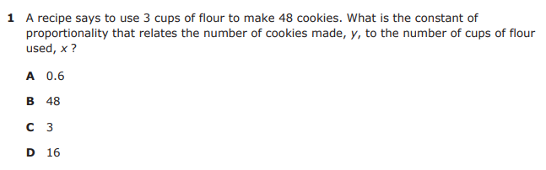

7.4E – 3 (S.) nine Y
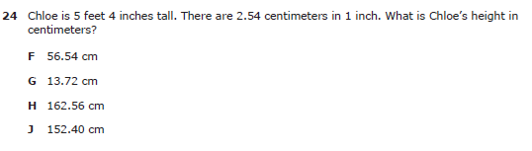

7.4E – 3 (S.) ten X
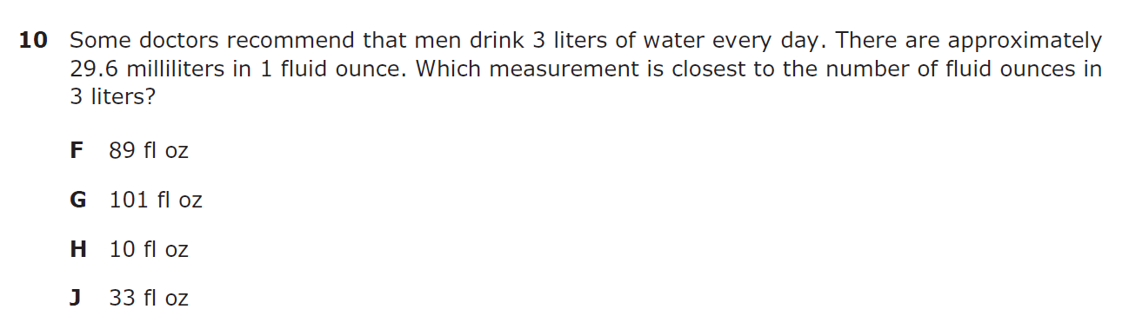

7.4E – 3 (S.) eleven W
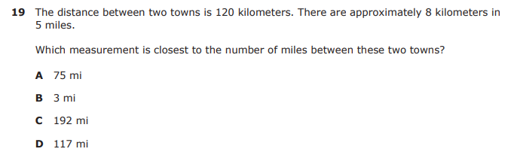

7.5A – 3 (S.) twelve Z
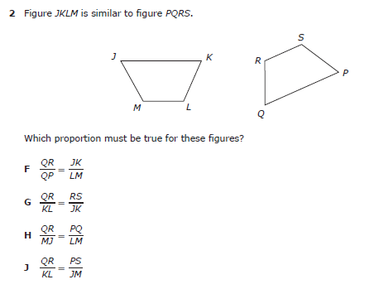

7.5A – 3 (S.) tthirteen Y
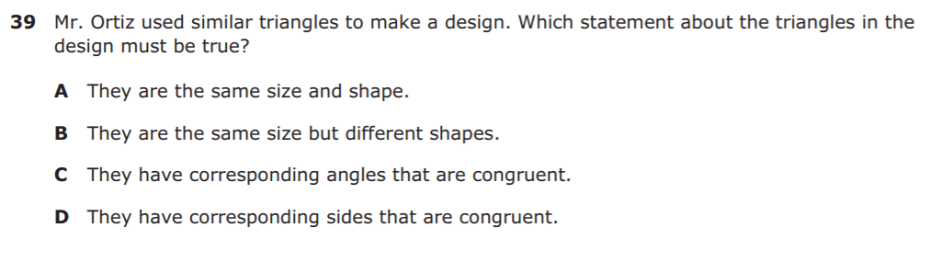

7.5A – 3 (S.) fourteen X
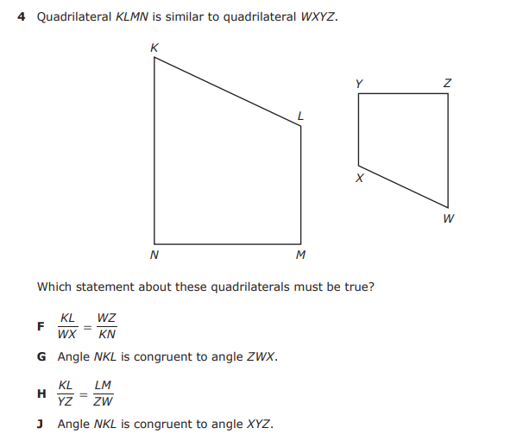

7.5B– 3 (S.) fifteen X
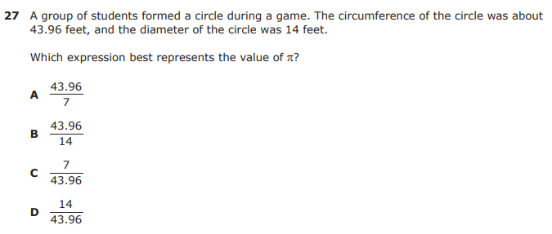

7.6A – 1 (S.) sixteen W
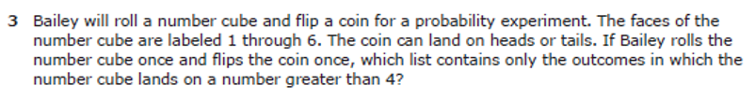

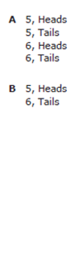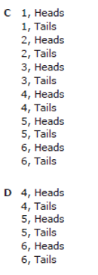
7.6A – 1 (S.) sixteen Y
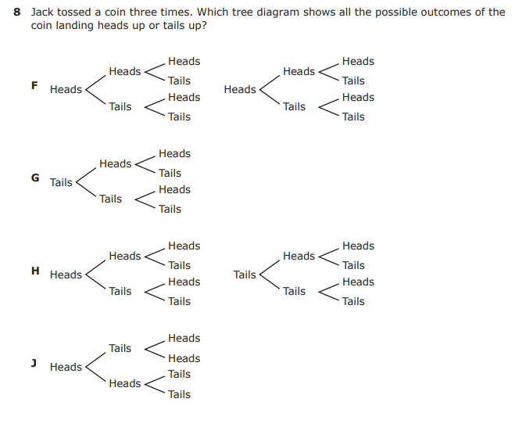
7.6C – 1 (S.) seventeen 490
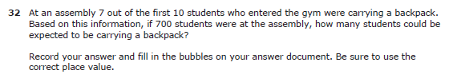
7.6C – 1 (S) eighteen Z
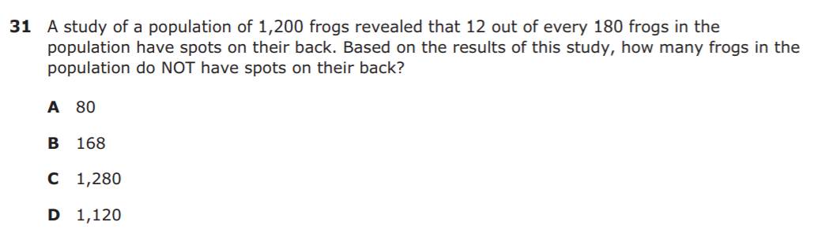

7.6D – 1 (S) nineteen Z
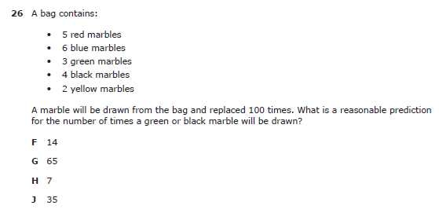

7.6D – 1 (S) twenty X
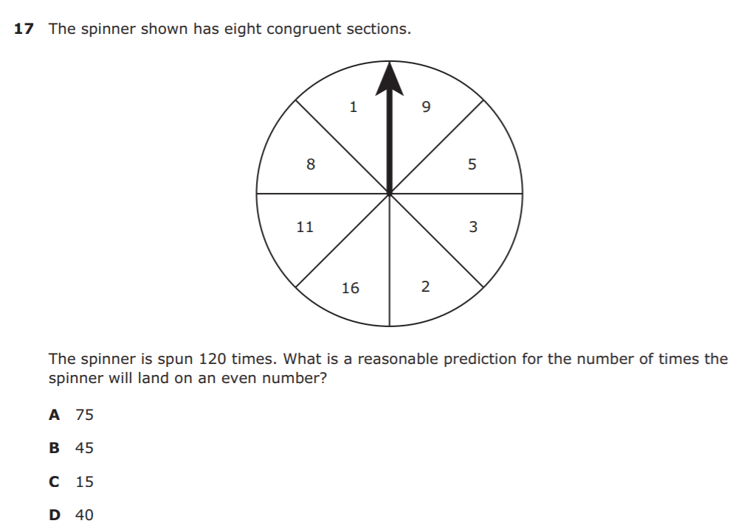
7.6E – 1 (S) twenty one Z
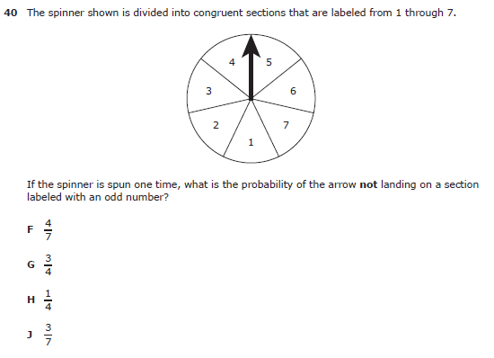
7.9D - 3 (S) twenty five W
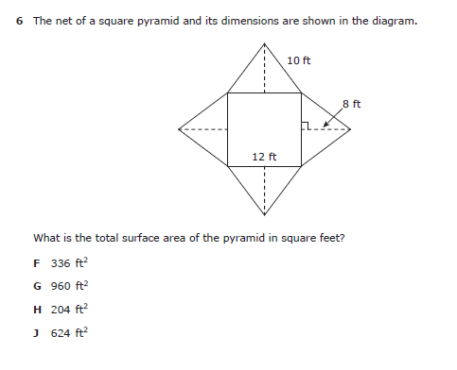
7.9D - 3 (S) twenty nine Z
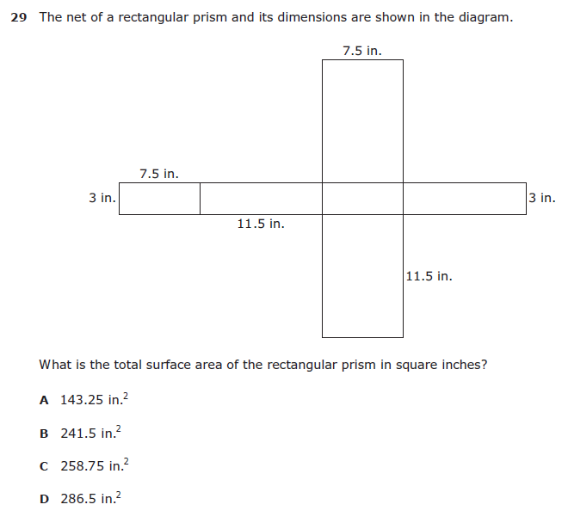
7.10A – 2 (S) thirty X

7.10A – 2 (S) thirty one Z

7.10B – 2 (S) thirty one X
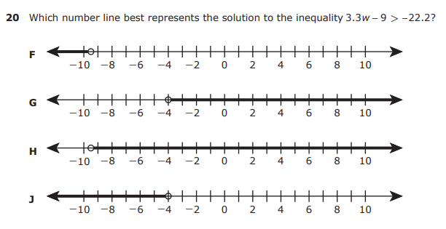

7.10C – 2 (S) thirty two W
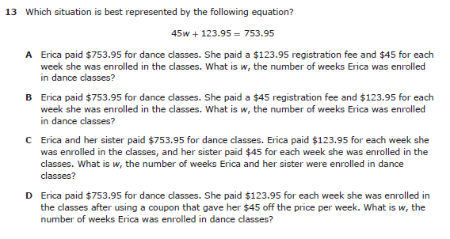

7.10C – 2 (S) thirty three W
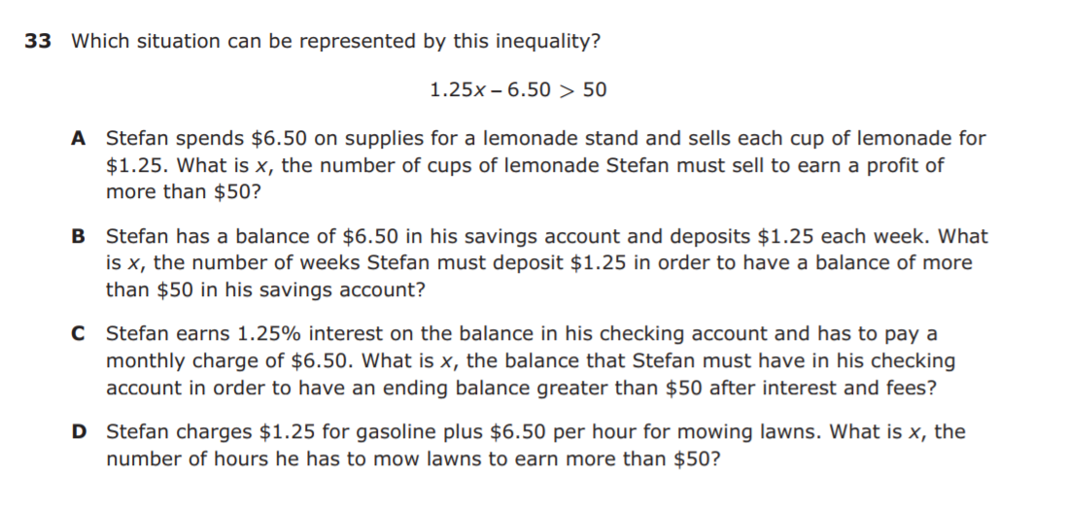

7.10C – 2 (S) thirty three X
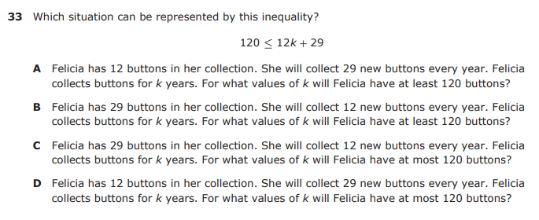

7.11B – 2 (S) thirty four W
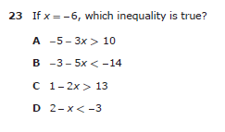

7.11B – 2 (S) thirty five Y
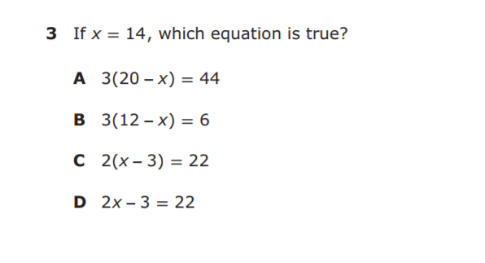

7.11B – 2 (S) thirty six Y
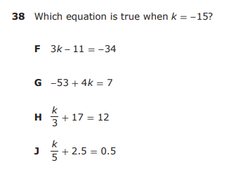

7.11C – 3 (S) thirty six X
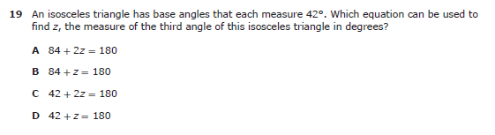

7.11C – 3 (S) thirty seven Z
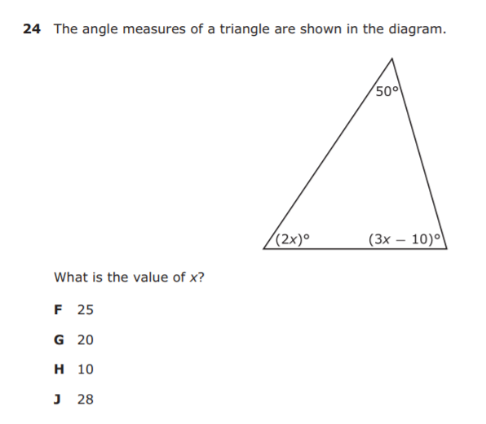
7.11C – 3 (S) thirty seven 5
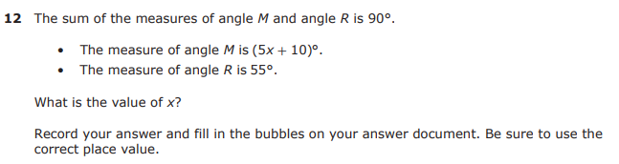
7.12B – 4 (S) thirty eight Y
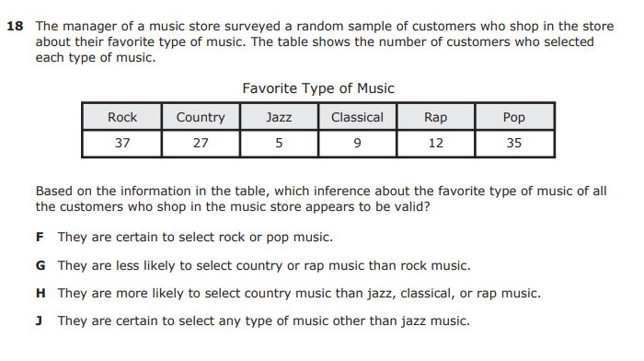

7.12C – 4 (S) thirty eight Z
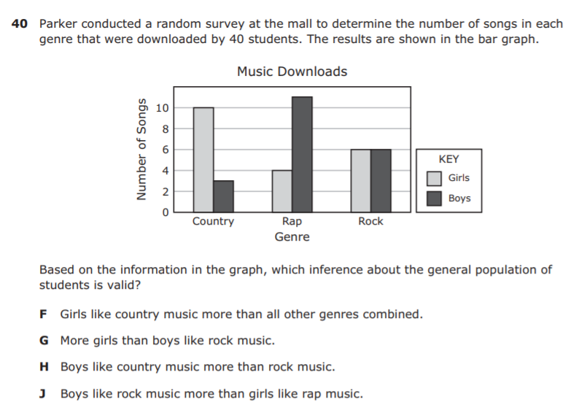
7.13A – 4 (S) thirty nine 31.53
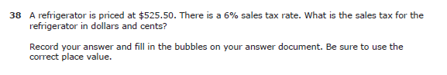
7.13A – 4 (S) forty 9127.50
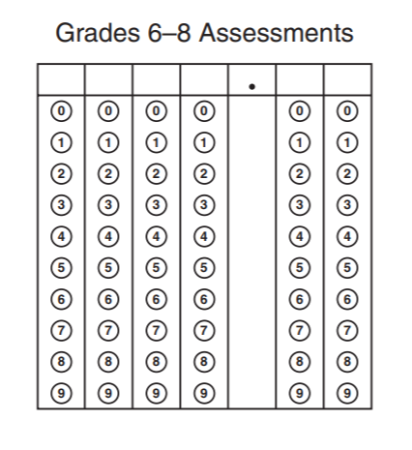
7.13A – 4 (S) forty 1.92
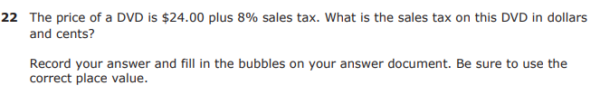
7.13B – 4 (S) forty one Z
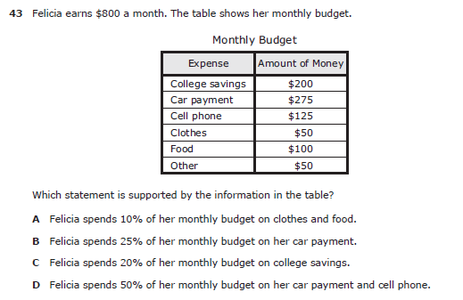

7.13B – 4 (S) forty one Y
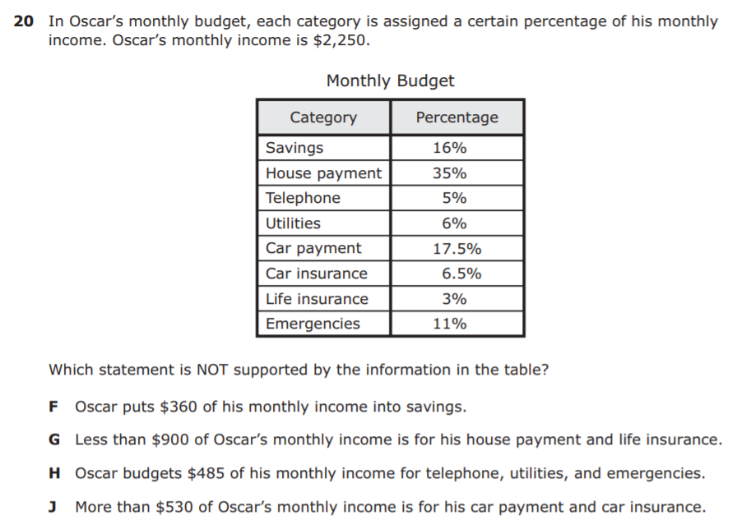
7.13C – 4 (S) forty two X
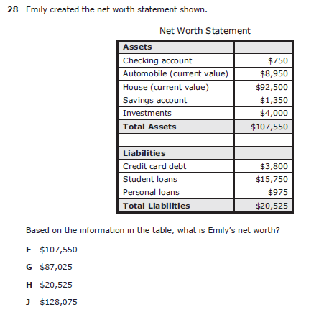
7.13C – 4 (S) forty two Y
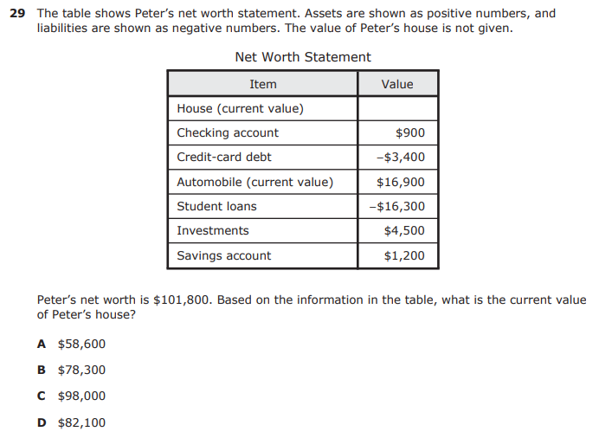

7.13E – 4 (S) forty three Z
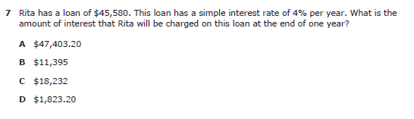

7.13F – 4 (S) forty four X
